POWER BI PROJECT REPORT
AML TRANSACTION
& FRAUD ANALYSIS
Interactive Financial Monitoring Dashboard Using Microsoft Power BI

Student Name | S. Thamilarasi
Register Number | E25FA048
Department | B.Com FinTech with AI
Project Tool | Microsoft Power BI
Academic Project

TABLE OF CONTENTS
- 1. Project Overview
- 2. Background and Need for AML Monitoring
- 3. Aim and Objectives
- 4. Dashboard Design and Key Indicators
- 5. Visual Analysis and Interpretation
- 6. Method Followed in Power BI
- 7. Business Applications
- 8. Findings and Learning Outcomes
- 9. Recommendations
- 10. Limitations and Future Scope
- 11. Conclusion
- 12. References

1. PROJECT OVERVIEW
This project presents an Anti-Money Laundering (AML) Transaction and Fraud Analysis dashboard created in Microsoft Power BI. The report brings together transaction activity, transaction value, fraud classification, account totals and alert categories in a visual format. The dashboard is intended to help a user review large volumes of financial activity and identify areas that may require closer checking.
The report is based on the three screenshots of the Power BI work completed for this project. The figures and chart patterns described below are the values visible in those screenshots; they should be treated as displayed dashboard results rather than independently recalculated figures.

2. BACKGROUND AND NEED FOR AML MONITORING
Banks and other financial service providers process many transactions every day. Most transactions are genuine, but some may show unusual patterns that need investigation. Anti-Money Laundering monitoring is used to review transactions and identify activity that may be connected with suspicious movement of money.
Checking each record separately can be time-consuming. A dashboard makes the information easier to scan by presenting totals, trends and categories together. It does not decide by itself that a person or transaction is involved in fraud. Instead, it helps analysts select records for further verification.

3. AIM AND OBJECTIVES
Aim: To build and interpret a Power BI dashboard that provides a visual overview of financial transactions and fraud-related indicators.
- Display the total number of transactions and the total transaction amount.
- Show the number of transactions marked as fraudulent.
- Present transaction activity across timestamp positions.
- Compare transaction amounts for fraud and non-fraud categories.
- Visualise the distribution of fraud labels and alert types.
- Provide a filter that allows the report viewer to focus on the IS_FRAUD category.
- Understand how dashboard visuals can support AML review and decision-making.

4. DASHBOARD DESIGN AND KEY INDICATORS
The dashboard uses KPI cards, line charts, a doughnut chart, a column chart, a horizontal bar chart and a fraud-category slicer. The purple report background and light-purple KPI panels provide a consistent visual theme, while blue chart marks make the data series easy to distinguish.
1M  Total Transactions | 153.48bn  Total Transaction Amount | 2K  Fraudulent Transactions

- Total Transactions – approximately 1 million transactions are displayed in the KPI card.
- Total Transaction Amount – the dashboard displays 153.48bn as the overall transaction amount.
- Fraudulent Transactions – the card displays approximately 2K transactions marked as fraudulent.
- Total Accounts – the dashboard displays approximately 10K accounts.

5. VISUAL ANALYSIS AND INTERPRETATION

5.1 Transaction count by timestamp
The line chart shows total transactions across timestamp positions from around 0 to 200. The line starts close to 5K, rises sharply near the beginning and then moves repeatedly up and down, mostly within the 6K–7K range. This indicates frequent variation across the displayed sequence, without a clear continuous upward or downward movement.

5.2 Transaction amount by timestamp
The transaction-amount line remains relatively low through the earlier timestamp positions. It begins to rise more noticeably in the later part of the chart and reaches roughly 4bn near the end. This visual suggests that the transaction amount is concentrated more heavily in the later observations. The underlying records should be checked to understand the reason for this pattern.

5.3 Fraud and non-fraud distribution
The doughnut chart divides transactions using the IS_FRAUD field. The visible labels show about 1M records (99.87%) classified as False and a much smaller share (0.13%) classified as True. This shows that the fraud-labelled portion is small compared with the non-fraud portion in the displayed data. A small percentage can still represent records that need review.

5.4 Transaction amount by fraud category
The column chart compares total transaction amount for False and True values of IS_FRAUD. The False category has a much taller bar, while the True category is comparatively small. This is consistent with the distribution shown in the doughnut chart. The exact values for each category should be read from the Power BI visual or its underlying data table.

5.5 Alert types
The horizontal bar chart displays the count of ALERT_ID by ALERT_TYPE. Two visible categories are cycle and fan_in. The cycle bar is longer than the fan_in bar, indicating a higher alert count for cycle in the displayed report. These alert categories can be used to prioritise which alert groups analysts review first.

6. POWER BI DASHBOARD SCREENSHOTS
The following figures are the screenshots supplied for this report. They show the dashboard layout and the visuals used for the analysis.
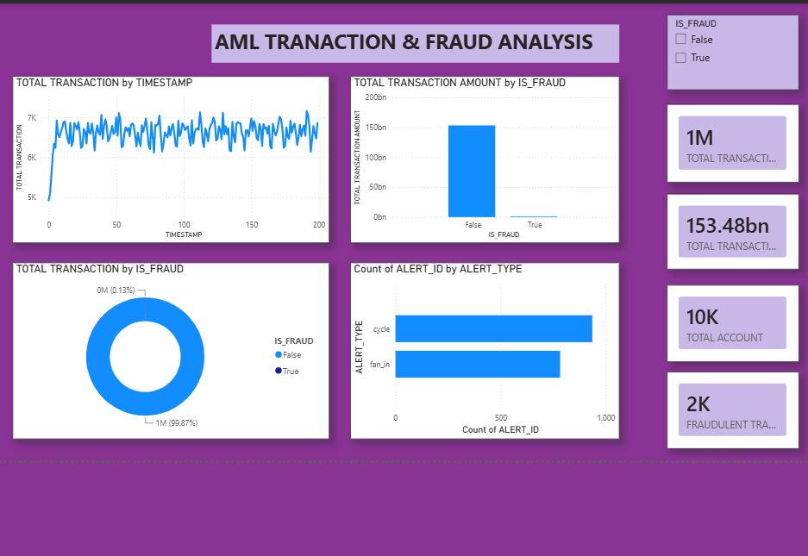
Figure 1: AML Transaction & Fraud Analysis dashboard with timestamp, fraud, alert-type visuals and KPI cards.
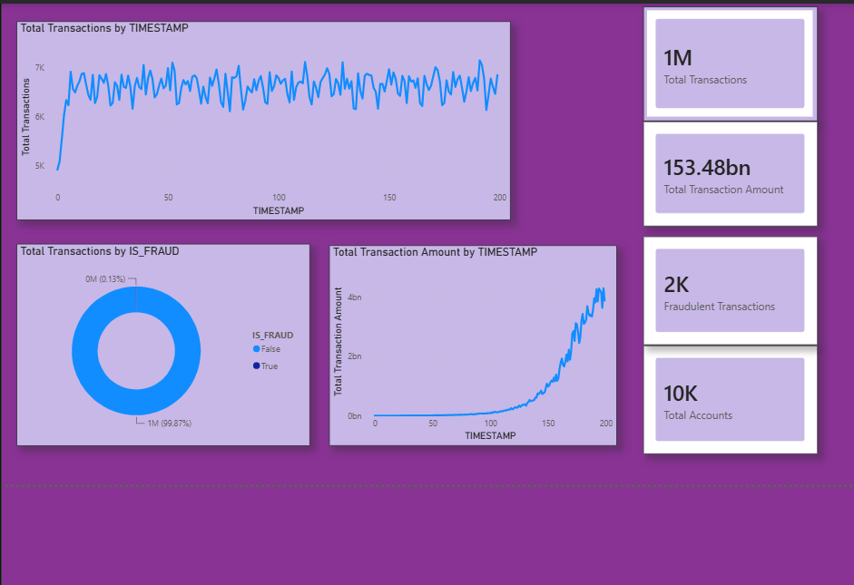
Figure 2: Transaction monitoring visuals showing transaction count and amount trends, fraud split and KPI indicators.
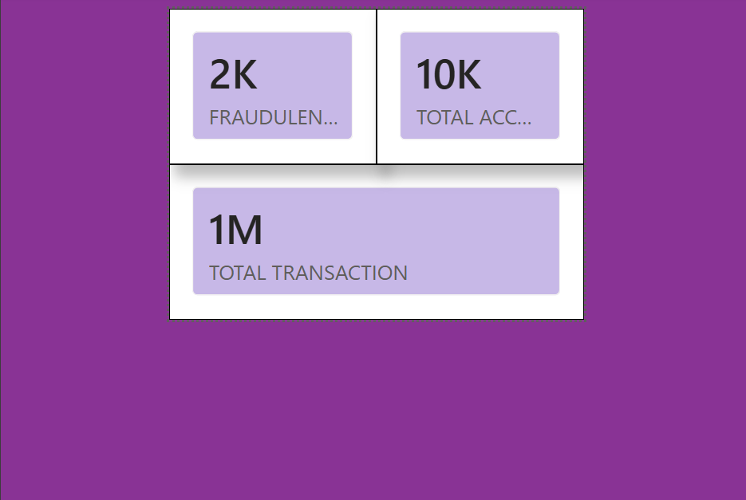
Figure 3: KPI card arrangement highlighting fraudulent transactions, total accounts and total transactions.

7. METHOD FOLLOWED IN POWER BI
- Load the financial transaction dataset into Power BI.
- Review the available fields, including TIMESTAMP, IS_FRAUD, ALERT_ID and ALERT_TYPE.
- Check that numeric fields and category fields have suitable data types.
- Create or select measures for transaction count, transaction amount, fraudulent transactions and total accounts.
- Add line charts to display transaction activity and transaction amount across timestamp positions.
- Use IS_FRAUD as the category for the doughnut and transaction-amount comparison visuals.
- Add an alert-type bar chart to compare the number of alerts in each category.
- Place KPI cards and the IS_FRAUD slicer on the report page, then format titles, labels and alignment.

8. BUSINESS APPLICATIONS
- AML monitoring: Provides a quick view of transaction activity and fraud-labelled records.
- Alert prioritisation: Helps analysts compare alert categories and decide where to begin a review.
- Operational reporting: Summarises large transaction datasets for managers and reporting teams.
- Trend review: Highlights periods or timestamp positions where transaction values change sharply.
- Data-quality checks: Unusual movements can prompt checks for missing values, duplicates or incorrect aggregation.

9. FINDINGS AND LEARNING OUTCOMES
Main observations from the dashboard:
- The dashboard displays approximately 1M total transactions and 10K total accounts.
- The total transaction amount KPI is shown as 153.48bn.
- The fraudulent transaction KPI is shown as approximately 2K.
- The fraud doughnut chart shows a very small True share compared with False.
- Transaction count fluctuates after an initial rise, while transaction amount increases strongly in the later timestamp positions.
- The cycle alert category has a higher displayed count than fan_in.
Skills developed through this project:
- Creating and arranging multiple Power BI visuals on a report page.
- Reading KPI cards, line charts, doughnut charts and bar charts.
- Using a category field to compare fraud and non-fraud records.
- Understanding how visual patterns can guide further investigation.
- Presenting financial information in a clear and organised dashboard.

10. RECOMMENDATIONS
- Add clear units and currency information to every transaction-amount visual.
- Use meaningful date labels if TIMESTAMP represents actual dates or times.
- Show exact values in tooltips so users can inspect individual points and categories.
- Provide filters for date, account, transaction type and alert type where the dataset supports them.
- Allow users to drill through from summary visuals to the related transaction records.
- Review fraud-labelled transactions using supporting evidence and approved investigation procedures.
- Keep KPI definitions consistent so that transaction counts and transaction amounts are not confused.

11. LIMITATIONS AND FUTURE SCOPE
This report interprets the supplied dashboard screenshots. The original dataset, measure formulas, filter context and data-refresh details were not provided with the screenshots. Therefore, the displayed figures are reported as rounded dashboard values, and the reasons behind the chart patterns cannot be confirmed from the images alone. A True fraud label should be understood as a dataset classification, not as proof of criminal activity.
Future improvements may include:
- Adding date-based filters and monthly summaries.
- Creating drill-through pages for transaction-level investigation.
- Adding trend comparisons between selected periods.
- Including additional alert categories and account-level analysis.
- Introducing anomaly-detection methods only after validating the data and the method.
- Documenting data sources, refresh frequency and the definitions of each KPI.

12. CONCLUSION
The AML Transaction and Fraud Analysis project demonstrates how Microsoft Power BI can turn financial transaction data into an interactive visual report. The dashboard combines key totals with transaction trends, fraud classification and alert-type comparisons. These visuals make it easier to understand the overall activity and identify areas that may need further attention.
The dashboard is a decision-support tool, not a substitute for a detailed AML investigation. Its usefulness depends on accurate data, clearly defined measures and careful interpretation. By completing this project, I gained practical experience in building financial dashboards and presenting transaction information through Power BI.

REFERENCES
- Microsoft Learn – Power BI documentation.
- Microsoft Learn – Power Query documentation.
- Microsoft Learn – DAX function reference.
- Microsoft Learn – Power BI visualizations documentation.

